A Brief History of the Yield Sign
In 1950, the world’s first yield sign was posted at the corner of First Street and Columbia Avenue in Tulsa, Oklahoma. Before the sign was introduced, this intersection was considered one of the most dangerous in Tulsa. Although there was already a right of way law in place, it was difficult to enforce, and many drivers failed to abide by these rules. Officer Clinton Riggs, a Tulsa native and police officer, had begun developing a sign that he hoped would alleviate these problems. He also wanted to assign clear blame in the event of a collision and hoped his sign would make liability clear.
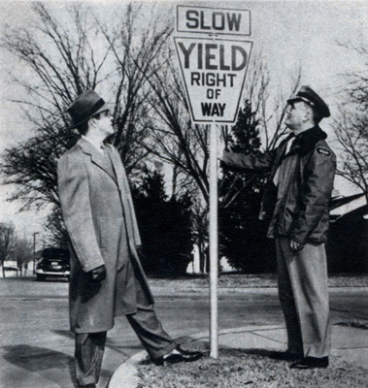
The original yield sign was keystone shaped and read “Yield Right of Way” in black letters on a bright background. Originally, yellow was used because reflective material was not yet available and yellow was the most visible color at night. Within a year of the sign’s posting, accident rates dropped dramatically, and drivers learned to approach the intersection with caution. Inspired by the success of the original sign, Tulsa posted more yield signs and spread the word to neighboring cities.
The Manual on Uniform Traffic Control Devices (MUTCD) added the yield sign in 1954 to assign right of way at intersections where a stop was not normally required. However, rather than a keystone, the yield sign was now shaped like a point-down equilateral triangle with black lettering and border, though the sign remained yellow. Triangles are highly visible and draw the eyes, making them better signs for drivers looking for immediate information. Yield signs are the only signs that are shaped like a triangle, the unique shape makes them difficult to miss. By September 1956, the St. Petersburg Times, a Florida newspaper, printed an article that detailed the use of a yield sign and commented on its wide spread.
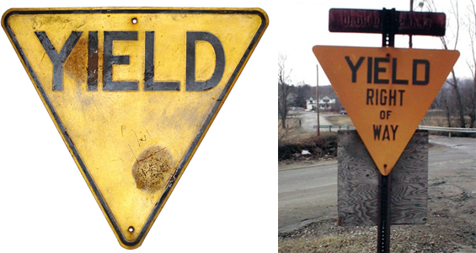
The sign gradually stopped including “right of way” and, by this time, simply read “yield.” The MUTCD describes the other factors that must be considered when installing yield signs . Yield signs are used to assign right of way and instruct drivers when they need to stop and slow down. They should be posted in an unobstructed place where sightlines make it difficult to see oncoming traffic.
In 1971, the MUTCD stipulated that yield signs should be red with a white triangle in the center and red lettering. The signs were changed in color because red is thought to be more attention grabbing. Prior to the 70s yellow was the most visible color, but the invention of reflective film made it possible to post signs in a variety of colors. These signs have grown in popularity all around the world and are used more often than stop signs in many European countries.
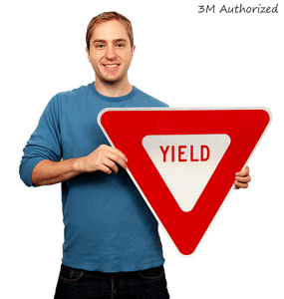
Yield signs have proven to be an invaluable addition to road safety. Intersections that employ them have both decreased in collisions and given a clear look at who is liable in the event of such an accident, just as Clinton Riggs hoped.

